**Year 11 ATAR Chemistry**

**Investigation 1: Fuels**

**Part B**

**Name: Answer Key / 38**

1. An experiment was carried out to determine the heat of combustion (in kJ/mol)

for three different fuels (olive oil, methanol and biodiesel). The diagram below

shows the equipment used to conduct the experiment.

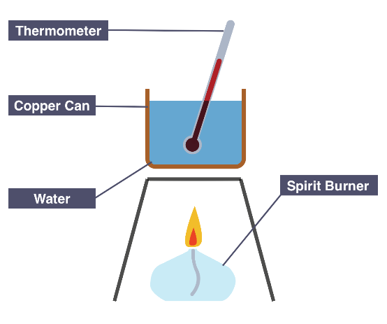

The spirit burner was weighed before and after heating. Approximately 100 g of water was placed in the copper can and the temperature of water before and after heating was recorded.

a) State three controlled variables for this experiment.

(Remember units and values where necessary.) (4 marks)

**Any 3 relevant variables for 3 marks and 1 mark for units/values**

* **Same volume of water (100 mL)**
* **Same temperature of starting water (°C)**
* **Wick the same length (mm)**
* **Same type of spirit burner used for each fuel**
* **Fuel burnt for same length of time (5 min)**
* **Can held same distance above flame**

The following results were obtained.

|  |  |  |  |  |  |  |  |
| --- | --- | --- | --- | --- | --- | --- | --- |
| Fuel | Formula | Initial mass of fuel and burner (g) | Final mass of fuel and burner (g) | Mass of fuel burned  (g) | Initial temp. of water  (°C) | Final temp. of water  (°C) | Temp. change  (°C) |
| Olive oil | C18H34O2 | 204.60 | 204.51 | **0.09** | 22.9 | 43.0 | **20.1** |
| Methanol | CH3OH | 239.39 | 238.79 | **0.60** | 22.9 | 51.8 | **28.9** |
| Biodiesel | C19H34O2 | 190.20 | 190.09 | **0.11** | 22.9 | 41.5 | **18.6** |

**(1) (1)**

b) Complete the results table above by filling in the missed columns. (2 marks)

c) Using the formula given below and the experimental results, calculate the heat energy in joules absorbed by the water from burning each of the fuels. (3 marks)

Energy(J) = mass of water (g) x specific heat x temperature

capacity of water difference

(specific heat capacity of water = 4.180 J/g°C)

**Energy (Olive oil) = 100 x 4.180 x 20.1**

**= 8 401.8 J (1)**

**Energy (Methanol) = 100 x 4.180 x 28.9**

**= 12 080.2 J (1)**

**Energy (Biodiesel) = 100 x 4.180 x 18.6**

**= 7 774.8 J (1)**

d) Complete the table below by calculating the moles of each fuel burnt and hence the energy released (J/mol) by each fuel. (6 marks)

|  |  |  |  |  |
| --- | --- | --- | --- | --- |
| Fuel | Formula | Molar Mass of fuel  (g mol-1) | Moles of fuel  used  (mol) | Energy  released  (J/mol) |
| Olive oil | C18H34O2 | 282.452 | **3.186 x 10-4** | **2.637 x 107** |
| Methanol | CH3OH | 32.042 | **1.873 x 10-2** | **6.451 x 105** |
| Biodiesel | C19H34O2 | 294.462 | **3.736 x 10-4** | **2.081 x 107** |

e) Write balanced equations for the complete combustion of olive oil and methanol.

(4 marks)

**2 C18H34O2 + 51 O2 🡪 36 CO2 + 34 H2O**

**(1 – correct species 1 – balanced)**

**2 CH3OH + 3 O2 🡪 2 CO2 + 4 H2O**

**(1 – correct species 1 – balanced)**

f) Describe two **major** sources of experimental error within this investigation. (2 marks)

**Here, students had to show an understanding of the major sources of error.**

**Errors to mention were any of:**

* **heat lost on the sides that isn’t use in heating water as there is no insulation**
* **Draft in the room, flame moving inconsistently**
* **Wick not always same length and surface area.**
* **Wick sometimes dry, sometimes moistened at begin of heating.**
* **Temperature still increasing when flame extinguished.**

**Don’t award marks for weighing error or timing as this is probably the most accurate part of the experiment.**

2. Diesel is a fuel that can be obtained from crude oil. It is used in most forms of

transport, from trucks, cars and tractors to aircraft and rail cars. Biodiesel is most

commonly produced from vegetable oil in a chemical reaction called transesterification.

It can be used in pure form, in many of the same vehicles as regular diesel, however it

is often used as a biodiesel-diesel mix.

a) Briefly describe two (2) advantages of using biofuels instead of fossil fuels as an

energy source. (2 marks)

**(Any 2 relevant points)**

* **use renewable resources rather than non-renewable**
* **lower overall CO2 emissions**
* **decreased environmental impact such as global warming / polar ice caps melting / ocean acidification**
* **more sustainable process**

b) State two (2) reasons it is not always possible for people to use biofuels. (2 marks)

**(Any 2 relevant points)**

* **not available to lots of people / countries / places in the world**
* **expensive**
* **new technology / processes not developed properly yet**
* **not available on large enough scale for general public**

The table below gives some information regarding diesel and biodiesel.

|  |  |  |  |
| --- | --- | --- | --- |
|  | Formula | Molecular mass  (g mol-1) | Energy output (kJ g-1) |
| Diesel | C18H34 | **250.452 (1)** | 44.98 |
| Biodiesel | C18H36O2 | **284.468 (1)** | 38.48 |

c) Complete the table by calculating the molecular mass (g mol-1) of each fuel. (2 marks)

d) Calculate the energy output of **diesel** in kilojoules per mole (kJ mol-1).

(2 marks)

**n(diesel in 1g) = 1 / 250.452**

**= 3.993 x 10-3 mol (1)**

**energy output in kJ / mol = 44.98 / 3.993 x 10-3**

**= 11 265.33 kJ mol-1 (1)**

The equation for the combustion of **biodiesel** is shown below.

C18H36O2(l) + 26 O2(g) → 18 CO2(g) + 18 H2O(l) + 10946 kJ

If a sample of biodiesel was combusted and 9625 kg of CO2(g) was released into the atmosphere;

e) Calculate the mass of biodiesel that would have been consumed. Express your answer

to the appropriate number of significant figures. (5 marks)

**m(CO2) = 9.625 x 106 g (1)**

**n(CO2) = m/M**

**= 9.625 x 106 / 44.01**

**= 218 700.2954 mol (1)**

**n(biodiesel) = n(CO2)/18**

**= 218 700.2954 / 18**

**= 12 150.01641 mol (1)**

**m(biodiesel) = nM**

**= 12 150.01641 x 284.468**

**= 3 456 290.868 g (1)**

**= 3.456 x 106 g (4SF) (1)**

f) Calculate the amount of energy released. (2 marks)

**energy released = n(biodiesel) x 10 946**

**= 12 150.01641 x 10 946 (1)**

**= 132 994 079.6 kJ**

**= 1.330 x 108 kJ (1)**

**OR**

**energy released = n(CO2) / 18 x 10946**

**= 218 700.2954 / 18 x 10946**

**= 132 994 079 kJ**

**= 1.330 x 108 kJ**

g) What mass of **diesel** would have been needed to release this same amount of energy? (2 marks)

**mass diesel = energy released / Energy output diesel (kJ g-1)**

**= 132 994 079 kJ / 44.98 kJ g-1 (1)**

**= 2 956 738 g diesel required**

**= 2.957 kg (1)**

**OR**

**Comparing kJ mol-1 values;**

**n(diesel) = 132 994 079 kJ / 11 265 kJ mol-1**

**= 11 805.6 moles**

**m(diesel) = nM**

**= 11 805.6 x 250.452**

**= 2 956 738 g**

**= 2.957 t diesel required**